**UNIX Introduction**

**Unix/Linux Introduction:**

Unix is an operating system which is developed in early 60’s by AT&T labs employees at Bell labs. The initial developers includes Ken Thomson and Dennis Ritchie. It is the base Operating system of other operating systems such as Solaris, Posix, MacOS, Ubuntu, etc…

And it is written in c programming language.

**Architecture:**

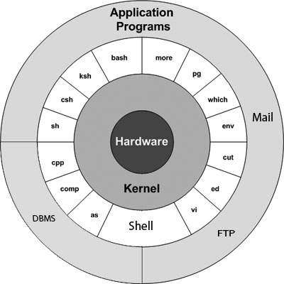

**Kernel:**

Kernel is like central core of an operating system. It provides interface between hardware devices, Memory and I/O management. The main functions are..

* Process Management.
* Memory management.
* Device Management.
* Interrupt Handling.
* I/O Communication.

**Kernel Sub Systems are:**

* *Concurrency*: As Unix is a multiprocessing OS, many processes run concurrently (simultaneously) to improve the performance of the system.
* *Virtual memory (VM)*: Memory management subsystem implements the virtual memory concept and users need not worry about the executable program size and the RAM size.
* *Paging*: It is a technique to minimize the internal as well as the external fragmentation in the physical memory.
* *Virtual file system (VFS)*: A VFS is a file system used to help the user to hide the different file systems complexities. A user can use the same standard file system related calls to access different file systems.

The kernel provides these and other basic services also: interrupt and trap handling, separation between user and system space, system calls, scheduling, timer and clock handling, file descriptor management.

**Shell:**

The shell is a type of program called an *interpreter*. An interpreter operates in a simple loop: It accepts a command, interprets the command, executes the command, and then waits for another command. The shell displays a "prompt," to notify you that it is ready to accept your command.

Read Command

Interpret Command

Execute Command

Display Prompt

**LINUX Introduction:**

Developed by Linus Torvalds in 90’s as hobby to play games. Whereas UNIX is not very much graphic friendly and it is a premium version. But, Linux is an open source operating system. It is works on Linux kernel.

Linux is a clone of Unix. The Initial Linux is just a kernel and later it’s developed into a complete operating system. Whereas unix is a complete operating systems.

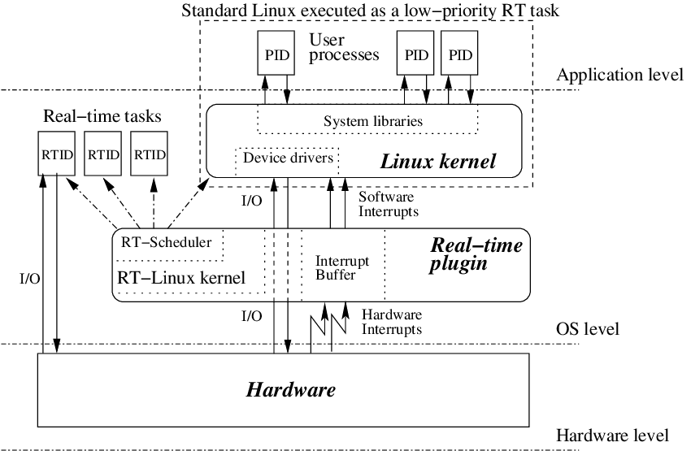

|  |  |  |
| --- | --- | --- |
| Comparison | Linux | Unix |
| Cost | Linux is freely distributed, downloaded through magazines, Books, website, etc. There are paid versions also available for Linux. | Different flavors of Unix have different pricing depending upon the type of vendor. |
| Development | Linux is Open Source, and thousands of programmer collaborate online and contribute to its development. | Unix systems have different versions. These versions are primarily developed by AT&T as well as other commercial vendors. |
| Users | Everyone. From home users to developers and computer enthusiasts alike. | The UNIX can be used in internet servers, workstations, and PCs. |
| Text mode interface | BASH is the Linux default shell. It offers support for multiple command interpreters. | Originally made to work in Bourne Shell(sh). However, it is now compatible with many others software. |
| GUI | Linux provides two | Common Desktop Environment and also has Gnome. |
| GUIs,viz., KDE and Gnome. Though there are many alternatives such as Mate, LXDE, Xfce, etc. |
| Viruses | Linux has had about 60-100 viruses listed to date which are currently not spreading. | There are between 80 to 120 viruses reported till date in Unix. |
| Threat detection | Threat detection and solution is very fast because Linux is mainly community driven. So, if any Linux user posts any kind of threat, a team of qualified developers starts working to resolve this threat. | Unix users require longer wait time, to get the proper bug fixing patch. |
| Architectures | Initially developed for Intel’s x86 hardware processors. It is available for over twenty different types of CPU which also includes an ARM. | It is available on PA-RISC and Itanium machines. |
| Usage | Linux OS can be installed on various types of devices like mobile, tablet computers and servers. | The UNIX operating system is used for internet servers, workstations & PCs. |
| Best feature | Kernel update without reboot | Feta ZFS – next generation filesystem DTrace – dynamic Kernel Tracing |
| Versions | Different Versions of Linux are Redhat, Ubuntu, OpenSuse, etc. | Different Versions of Unix are HP-UX, AIS, BSD, etc. |
| Supported file type | The Filesystems supported by file type like xfs, nfs, cramfsm ext 1 to 4, ufs, devpts, NTFS. | The Filesystems supported by file types are zfs, hfx, GPS, xfs, vxfs. |
| Portability | Linux is portable and is booted from a USB Stick | Unix is not portable |
| Source Code | The source is available to the general public | The source code is not available to anyone. |